LMS Software Engineering Project Report

University: El-Neelian University
Student: Randa Abd-Elhameed Abd-Allah Abd-Elmahmoud
University number: 2-125812744
Course: Software Engineering
GitHub repository: https://github.com/randah362-tech/Lms-project
This report documents the Software Engineering practical project: an online Learning Management System (LMS), covering the software process, the Agile plan and the supporting models, written up stage by stage.

1. Project Overview
The system is a web-based LMS with three roles: Student, Teacher and Admin. Teachers create courses, upload content, and create and grade assignments and quizzes. Students enroll in courses, download content, submit assignments and view grades. Admins manage users and roles. The project is carried out individually and covers five areas: software process, Agile development, UML analysis and design, Git/GitHub management, and software engineering ethics.

1.1 Functional Requirements
Each requirement maps to a user story in the Product Backlog (Section 3.2).
ID | Requirement | Story
FR1 | A student can register an account | US1
FR2 | A user can log in and log out | US2
FR3 | An admin can manage users and roles | US3
FR4 | A user can reset a forgotten password by email | US4
FR5 | A user can view and edit their profile | US5
FR6 | A teacher can create a course | US6
FR7 | A teacher can upload course content | US7
FR8 | A student can enroll in a course | US8
FR9 | An enrolled student can download course content | US9
FR10 | A user can search for courses | US10
FR11 | A teacher can create an assignment | US11
FR12 | A student can submit an assignment before its deadline | US12
FR13 | A teacher can grade a submission | US13
FR14 | A teacher can create a quiz | US14
FR15 | A student can view their grades | US15
FR16 | A student can take a quiz | US16

1.2 Non-Functional Requirements
The targets below are proposed for this project and can be adjusted.
ID | Category | Requirement
NFR1 | Security | Passwords are stored hashed, and access is controlled by user role
NFR2 | Privacy | Only the minimum personal data is collected, and students see only their own grades
NFR3 | Usability | Core actions are reachable within 3 clicks from the dashboard
NFR4 | Performance | Pages respond within 3 seconds under normal load
NFR5 | Portability | The system works in modern desktop and mobile browsers
NFR6 | Maintainability | Modular code, with one Git branch per feature

2. Stage 1: Software Process

2.1 Candidate Process Models
The comparison covers the three models presented in the lecture (Waterfall, Incremental development, Integration and configuration), plus Spiral and Scrum. Weights and scores are out of 5.
Criterion | Weight | Waterfall | Incremental | Integration & Config | Spiral | Scrum
Requirements likely to change | 5 | 1 | 4 | 3 | 4 | 5
Early working release | 4 | 1 | 5 | 4 | 3 | 5
Risk management | 3 | 2 | 3 | 3 | 5 | 3
Simplicity (small team) | 4 | 4 | 4 | 3 | 2 | 4
User feedback | 5 | 1 | 4 | 3 | 4 | 5
Total |  | 36 | 85 | 67 | 75 | 95
Worked example (Spiral): (5×4) + (4×3) + (3×5) + (4×2) + (5×4) = 20 + 12 + 15 + 8 + 20 = 75.

2.2 Decision and Justification
The project uses Incremental-Iterative Development as the overall process, with Scrum as the Agile method inside it.
- In the lecture, incremental development interleaves specification, development and validation, and may be plan-driven or agile. This project uses the agile form.
- Scrum is not a separate model from incremental development; it is an agile way of running it. This links Stage 1 directly to Stage 2.
- The lecture states that there are no right or wrong software processes and that most practical processes mix elements of several models. The project therefore also borrows from Integration and configuration by reusing ready-made components (for example an authentication library and a video player).

2.3 Development Phases (repeated in every increment)
Phase | Output in the LMS project
Requirements definition | Functional and non-functional requirements
System and software design | UML diagrams and database schema
Implementation and unit testing | Code and unit tests
Integration and system testing | Component integration and system tests
Operation and maintenance | Release of the increment and improvements

2.4 Increments
- Increment 1: registration, login and role management
- Increment 2: course creation and content upload
- Increment 3: assignments, quizzes and grades

3. Stage 2: Agile Development with Scrum

3.1 Scrum Roles
The project is individual, so the student plays all three roles and switches between them. The course instructor acts as the stakeholder.
Role | Responsibility
Product Owner | Represents the needs of the university, teachers and students; orders the Product Backlog
Scrum Master | Keeps the team to the process and removes obstacles
Development Team | Design, implementation and testing

3.2 Product Backlog
Story points use a Fibonacci scale: 1, 2, 3, 5, 8.
ID | User Story (short) | Points | Sprint
US1 | A student registers an account | 3 | 1
US2 | A user logs in and out | 2 | 1
US3 | An admin manages roles | 5 | 1
US4 | A user recovers a forgotten password | 3 | 1
US5 | A user views and edits a profile | 2 | 1
US6 | A teacher creates a course | 5 | 2
US7 | A teacher uploads content | 5 | 2
US8 | A student enrolls in a course | 3 | 2
US9 | A student downloads content | 3 | 2
US10 | A user searches for a course | 2 | 2
US11 | A teacher creates an assignment | 5 | 3
US12 | A student submits an assignment | 5 | 3
US13 | A teacher grades a submission | 3 | 3
US14 | A teacher creates a quiz | 5 | 3
US15 | A student views their grades | 2 | 3
US16 | A student takes a quiz | 3 | 3

3.3 Example User Story with Acceptance Criteria
US12: As a student, I want to submit my assignment before the deadline, so that my teacher can grade it.
Acceptance criteria:
- Only a student enrolled in the course can submit.
- The system rejects submissions after the deadline.
- The student sees a confirmation after submitting.

3.4 Sprint Plan
Sprint | Increment | Points | Calculation | Due date
1 | Registration and roles | 15 | 3+2+5+3+2 | November 1, 2026
2 | Courses and content | 18 | 5+5+3+3+2 | November 5, 2026
3 | Assignments and quizzes | 23 | 5+5+3+5+2+3 | November 8, 2026
Total |  | 56
Estimated velocity = (15 + 18 + 23) ÷ 3 ≈ 18.7 points per sprint.
Burndown (points remaining):
Point in time | Points remaining
Start | 56
After Sprint 1 | 41
After Sprint 2 | 23
After Sprint 3 | 0

3.5 Scrum Events (adapted for individual work)
Event | Purpose | Individual adaptation
Sprint Planning | Select stories from the Product Backlog into the Sprint Backlog | A written list at the start of each sprint
Daily Scrum | What was done, what is next, obstacles | A three-line daily log
Sprint Review | Demonstrate the working increment | Demo to the instructor or a peer, or screenshots and a short recording
Sprint Retrospective | What to improve next sprint | A written paragraph at the end of each sprint

3.6 User Stories and Acceptance Criteria
US12 appears in full in Section 3.3. The remaining stories follow the same format.
ID | User Story | Acceptance Criteria
US1 | As a student, I want to register an account, so that I can access my courses. | A valid email is required; a duplicate email is rejected; the password has at least 8 characters.
US2 | As a user, I want to log in and out, so that my account stays secure. | Valid credentials open the dashboard for my role; wrong credentials show an error; logout ends the session.
US3 | As an admin, I want to manage user roles, so that each user has the right permissions. | Only admins can open the page; a role change applies at the next login; each change is logged.
US4 | As a user, I want to reset my password, so that I can regain access to my account. | A reset link is sent by email; the link expires after 1 hour; the old password stops working after the reset.
US5 | As a user, I want to view and edit my profile, so that my details stay correct. | Name and password can be edited; a confirmation is shown after saving; a user cannot change their own role.
US6 | As a teacher, I want to create a course, so that students can enroll in it. | Title and description are required; the course appears in the catalogue; only its teacher can edit it.
US7 | As a teacher, I want to upload content to my course, so that students can study it. | PDF, PPTX and MP4 files are accepted; a file over 100 MB is rejected; the content appears under the course.
US8 | As a student, I want to enroll in a course, so that I can follow it. | A student can enroll once per course; the course appears on the dashboard; the enrollment date is stored.
US9 | As a student, I want to download course content, so that I can study offline. | Only enrolled students can download; an unauthenticated request is denied.
US10 | As a user, I want to search for courses, so that I can find the ones I need. | Search works by course title or teacher name; no results shows a clear message.
US11 | As a teacher, I want to create an assignment, so that students can submit their work. | Title, deadline and maximum grade are required; the deadline cannot be in the past; enrolled students can see it.
US13 | As a teacher, I want to grade a submission, so that students get feedback. | The grade is between 0 and the maximum grade; only the course teacher can grade; the student can see the grade.
US14 | As a teacher, I want to create a quiz, so that I can assess students. | A quiz has at least one question and a duration; multiple-choice answers are evaluated automatically.
US15 | As a student, I want to view my grades, so that I can track my progress. | A student sees only their own grades; grades are listed per course; an ungraded item shows Pending.
US16 | As a student, I want to take a quiz, so that I can be assessed. | Only enrolled students can start a quiz; the quiz closes when its duration ends; multiple-choice answers are evaluated automatically.

4. Stage 3: UML Modeling

4.1 Use Case Diagram
The use case diagram shows what each actor can do in the LMS. Student, Teacher and Admin inherit from the abstract actor User, so they share Login, Search Courses and View/Edit Profile. Email Service is a secondary actor used by Reset Password.
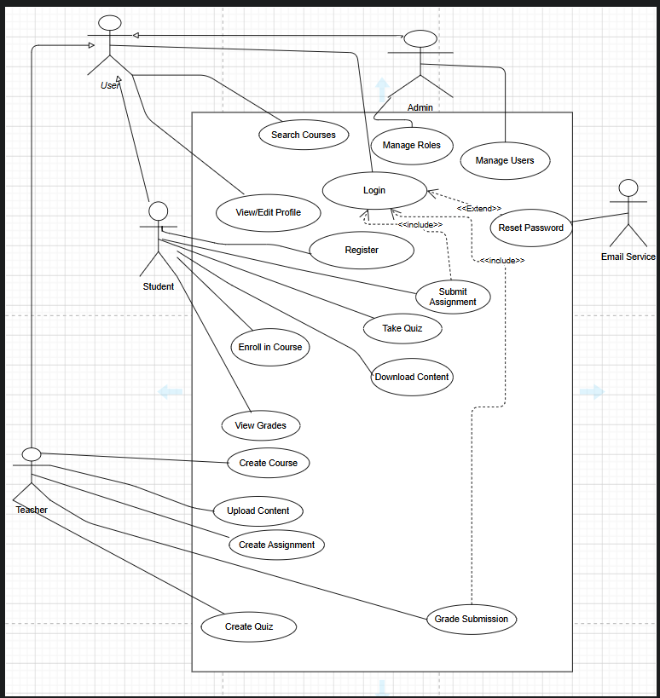
Relationships. Submit Assignment and Grade Submission include Login, and Reset Password extends Login. All other use cases except Register and Reset Password also require the user to be logged in.
Traceability to the Product Backlog
Use Case | Actor | User Story
Register | Student | US1
Login | User | US2
Manage Users, Manage Roles | Admin | US3
Reset Password | User, Email Service | US4
View/Edit Profile | User | US5
Create Course | Teacher | US6
Upload Content | Teacher | US7
Enroll in Course | Student | US8
Download Content | Student | US9
Search Courses | User | US10
Create Assignment | Teacher | US11
Submit Assignment | Student | US12
Grade Submission | Teacher | US13
Create Quiz | Teacher | US14
View Grades | Student | US15
Take Quiz | Student | US16

4.2 Class Diagram
The class diagram models the ten main classes of the LMS and the relationships between them.
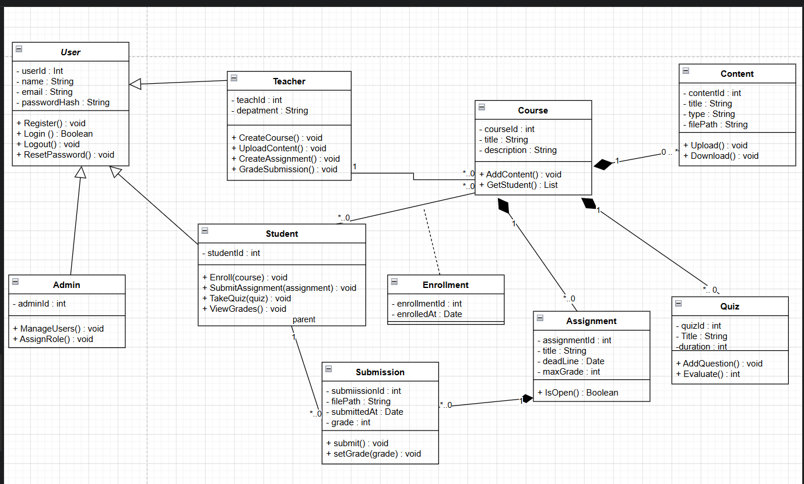
Relationships
Relationship | Type | Multiplicity
Student, Teacher, Admin → User | Generalization (User is abstract)
Teacher — Course | Association | 1 teacher : 0..* courses
Course — Content | Composition | 1 : 0..*
Course — Assignment | Composition | 1 : 0..*
Course — Quiz | Composition | 1 : 0..*
Assignment — Submission | Composition | 1 : 0..*
Student — Submission | Association | 1 : 0..*
Student — Course | Association (many-to-many), resolved by the Enrollment association class | 0..* : 0..*

4.3 Activity Diagram
The activity diagram models the Submit Assignment scenario (US12) with two swimlanes, Student and System. It follows the acceptance criteria of the story: only an enrolled student can submit, submissions after the deadline are rejected, and the student receives a confirmation.
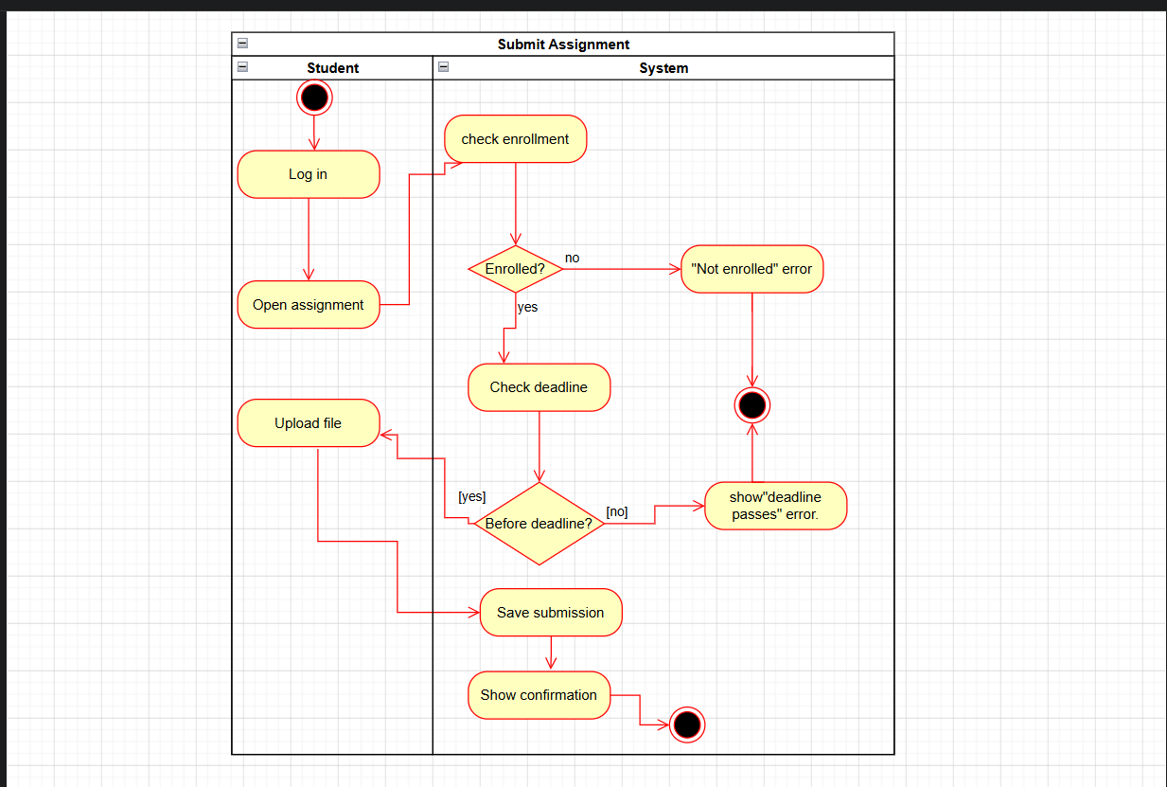

4.4 Sequence Diagram
The sequence diagram shows the message flow of the Submit Assignment scenario (US12) between the Student, the AssignmentController, and the Assignment, Enrollment and Submission objects. Two nested alt fragments cover the alternative flows: the student is not enrolled, or the deadline has passed.
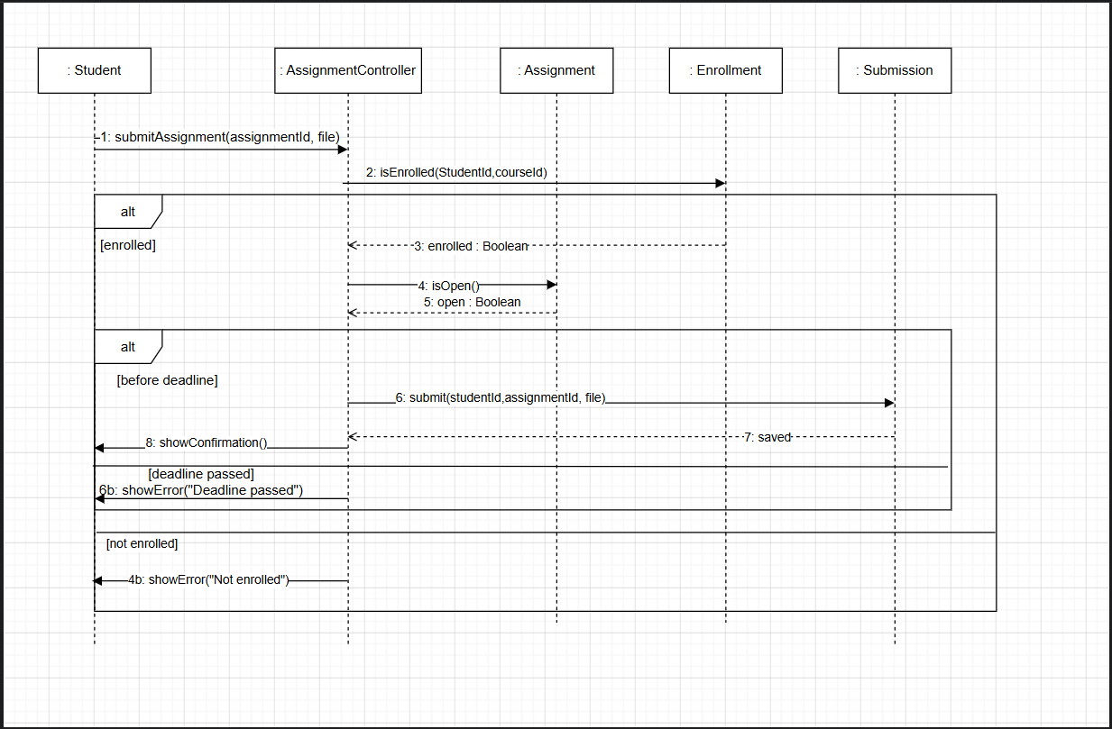

5. Database Design

5.1 Entity-Relationship Diagram
The class diagram was mapped to a relational schema of ten tables, one per class. The ERD uses crow's foot notation.
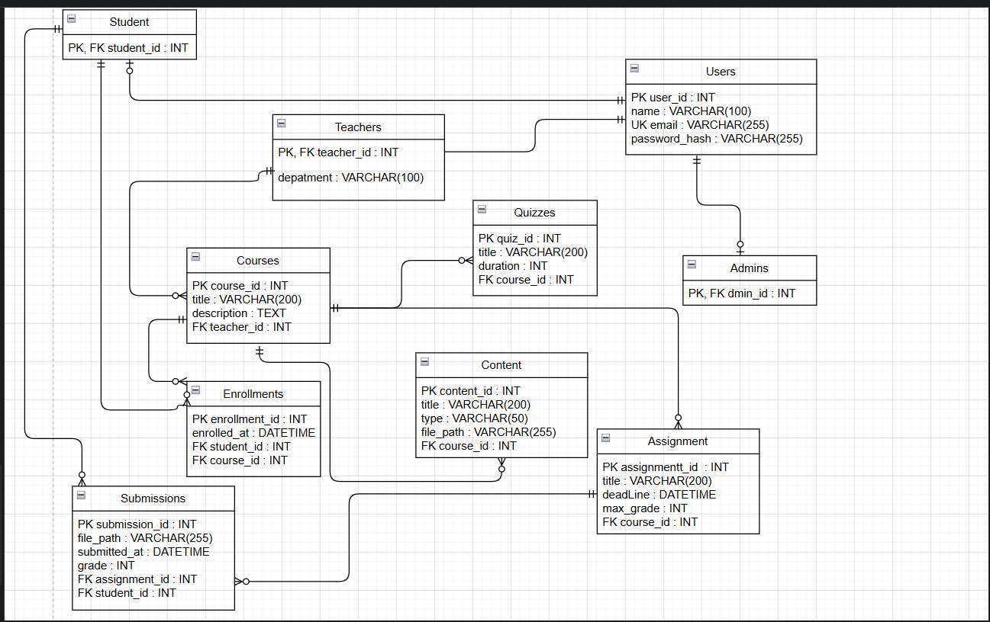

5.2 Relational Schema
PK is a primary key, FK a foreign key and UK a unique key.
Table | Columns
users | PK user_id : INT; name : VARCHAR(100); UK email : VARCHAR(255); password_hash : VARCHAR(255)
students | PK, FK student_id : INT → users
teachers | PK, FK teacher_id : INT → users; department : VARCHAR(100)
admins | PK, FK admin_id : INT → users
courses | PK course_id : INT; title : VARCHAR(200); description : TEXT; FK teacher_id : INT → teachers
contents | PK content_id : INT; title : VARCHAR(200); type : VARCHAR(50); file_path : VARCHAR(255); FK course_id : INT → courses
assignments | PK assignment_id : INT; title : VARCHAR(200); deadline : DATETIME; max_grade : INT; FK course_id : INT → courses
quizzes | PK quiz_id : INT; title : VARCHAR(200); duration : INT; FK course_id : INT → courses
enrollments | PK enrollment_id : INT; enrolled_at : DATETIME; FK student_id : INT → students; FK course_id : INT → courses
submissions | PK submission_id : INT; file_path : VARCHAR(255); submitted_at : DATETIME; grade : INT (nullable); FK assignment_id : INT → assignments; FK student_id : INT → students

5.3 Design Decisions
Decision | Reason
One table per class in the User hierarchy; the child primary key is also a foreign key to users | Students, teachers and admins share login data stored once in users
ON DELETE CASCADE on contents, assignments and quizzes | Implements the composition relationship: parts are deleted with their course
enrollments is an intermediate table, with (student_id, course_id) unique | Resolves the many-to-many Student–Course relationship and prevents duplicate enrollment
(assignment_id, student_id) unique in submissions | One submission per student per assignment
grade is nullable | A submission exists before it is graded

6. Version Control and Project Management with Git/GitHub
The project is managed in a public GitHub repository named Lms-project (https://github.com/randah362-tech/Lms-project). Git records the history of the work, and GitHub Issues, Milestones and a Project board are used to plan and track it. The figures in this section describe the repository at the time the screenshots were taken.

6.1 Repository and Branches
The repository has two branches: main, the default branch, and develop, the integration branch. The design and documentation files were committed directly to main. The final report is delivered through a pull request from develop into main (Section 6.7).
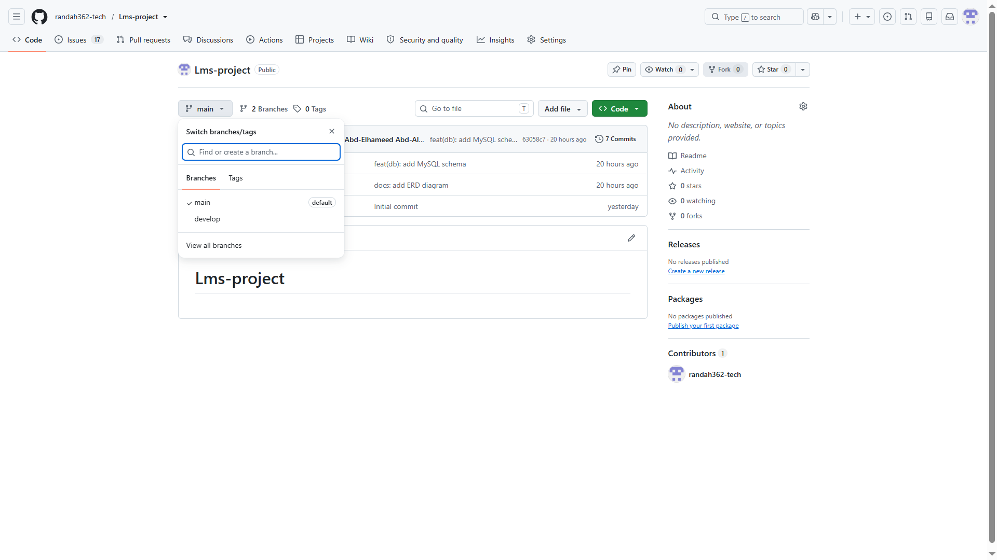

6.2 Commit History
The main branch has seven commits. Commit messages follow the Conventional Commits style, with a type such as docs or feat, an optional scope in parentheses, and a short description.
Commit | Message | Related issue
350516f | Initial commit | Repository creation
672082d | docs: add Use Case diagram | #19
6994820 | docs: add class diagram | #20
ba7323c | docs: add activity diagram | #21
2539b4c | docs: add sequence diagram | #22
7a368df | docs: add ERD diagram | #23
63058c7 | feat(db): add MySQL schema | #23
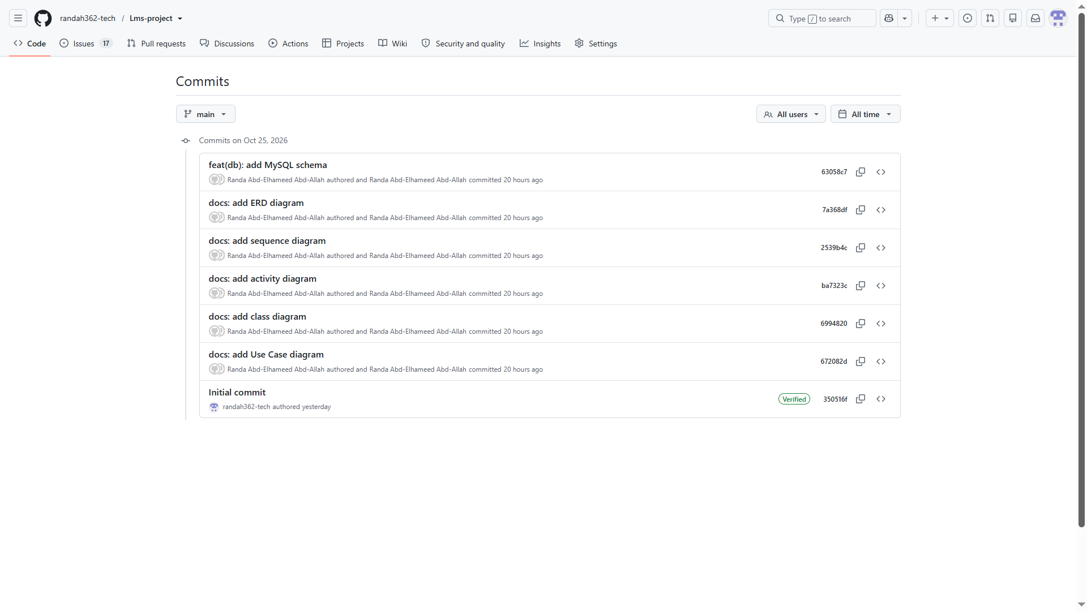

6.3 Issues and Labels
The repository holds 26 issues. Issues #1 to #16 are the user stories US1 to US16 from the Product Backlog, labeled user-story, with a sprint label and a points label. They were created first so that each issue number matches its story number. Issues #17 to #26 are the ten deliverables of the project, labeled deliverable and docs. When the screenshot was taken, 8 issues were closed and 18 were open.
Issue | Deliverable | Status
#17 | Software process: compare models and justify the choice | Closed
#18 | Agile plan: requirements, backlog, user stories and sprints | Closed
#19 | Use case diagram | Closed
#20 | Class diagram | Closed
#21 | Activity diagram: Submit Assignment | Closed
#22 | Sequence diagram: Submit Assignment | Closed
#23 | Database design: ERD and MySQL schema | Closed
#24 | Git/GitHub setup: repository, issues, milestones and project board | Open
#25 | Ethics: privacy, data protection and intellectual property | Closed
#26 | Finalize the report: cover page, conclusion and references | Open
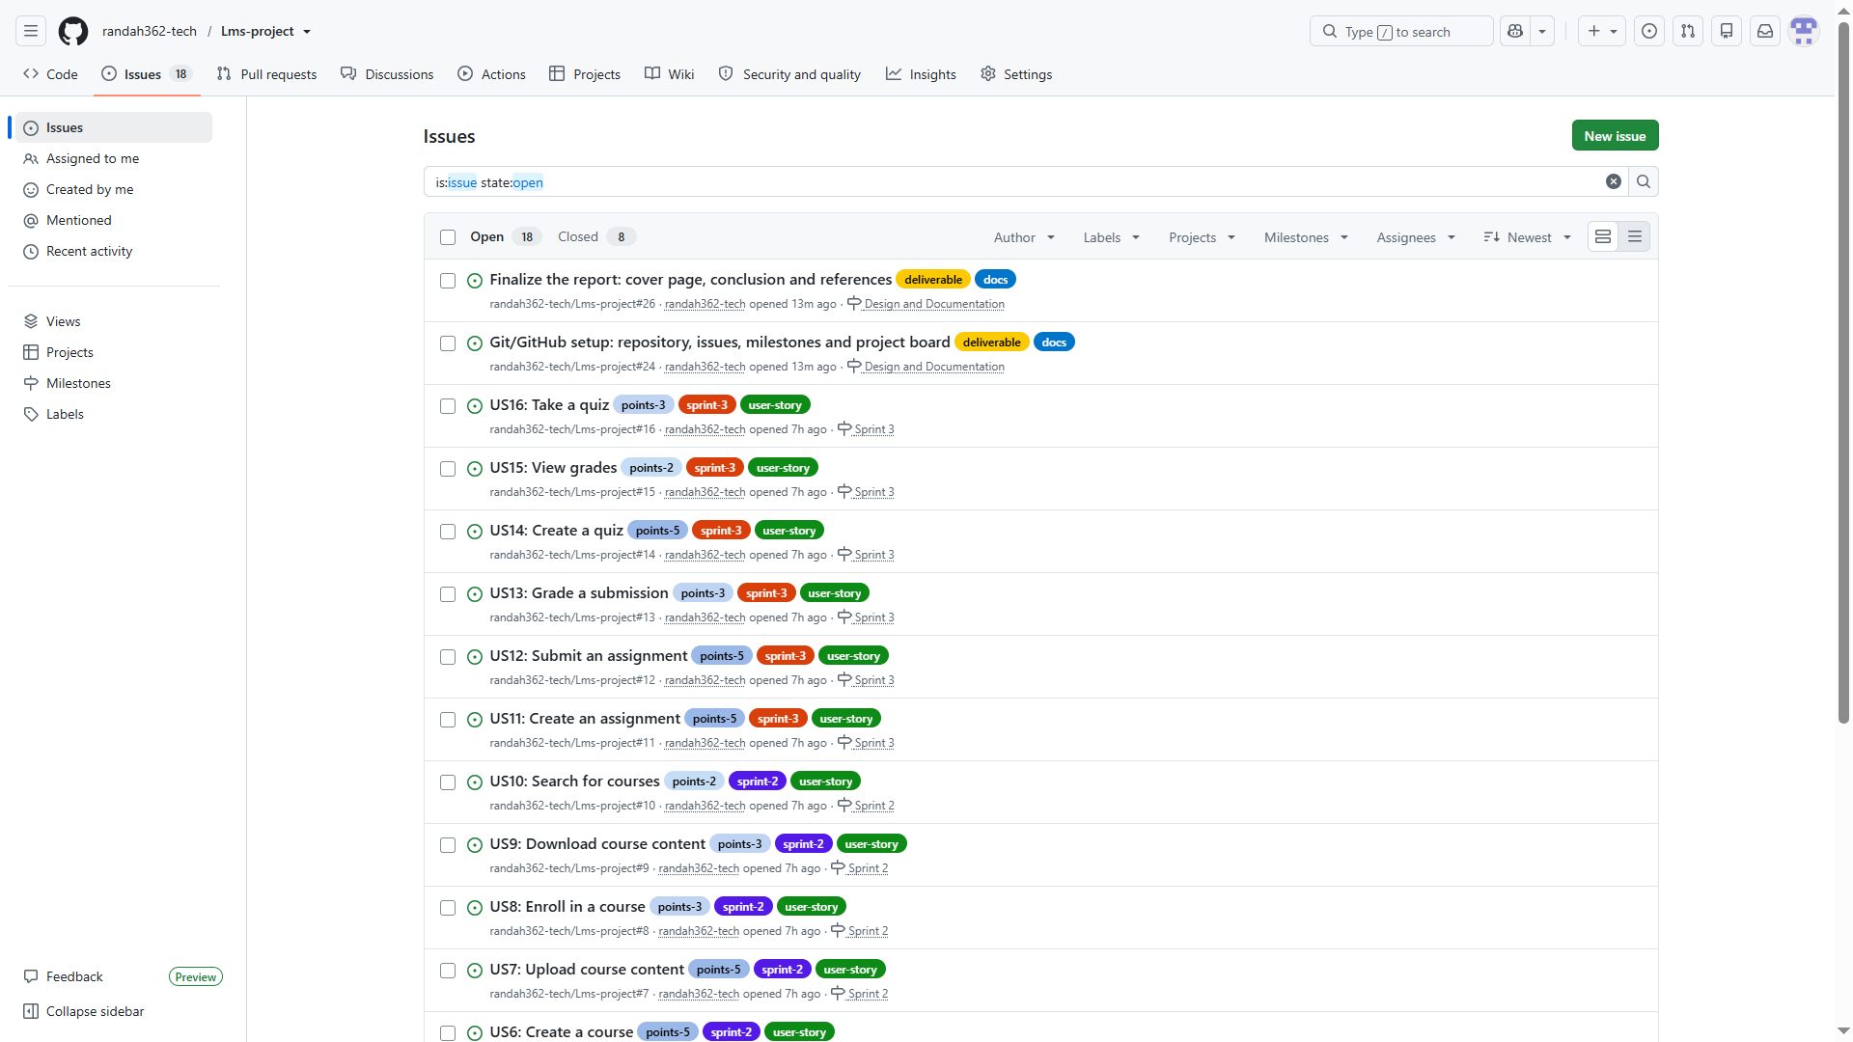

6.4 Milestones
The three sprints of the Agile plan are GitHub milestones, each with a real due date. A fourth milestone, Design and Documentation, groups the ten deliverable issues #17 to #26.
Milestone | Issues | Due date | Story points
Sprint 1 | US1 to US5 | November 1, 2026 | 15
Sprint 2 | US6 to US10 | November 5, 2026 | 18
Sprint 3 | US11 to US16 | November 8, 2026 | 23
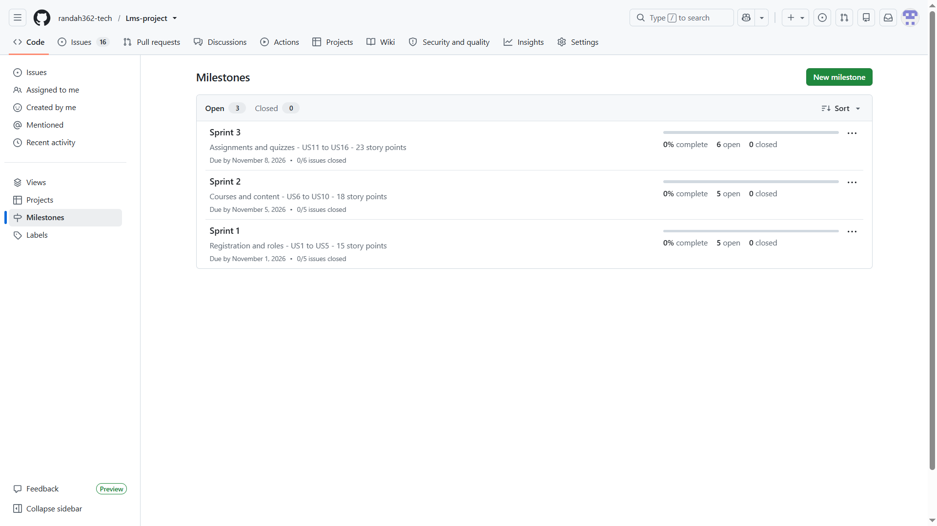
The Design and Documentation milestone is due on October 26, 2026. It holds the ten deliverable issues #17 to #26, of which 8 are closed and 2 are open (#24 and #26), so it is 80% complete.
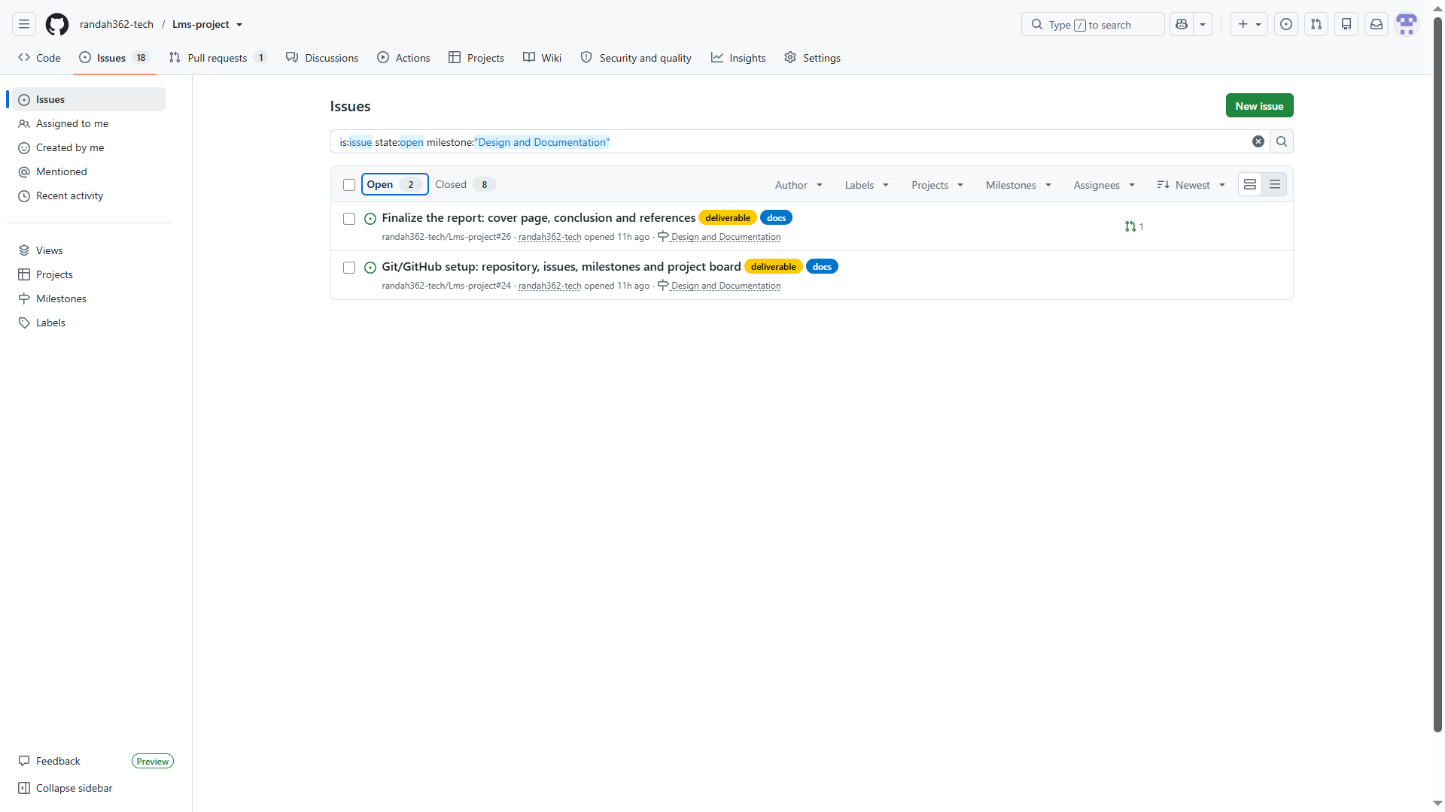

6.5 Project Board
The LMS Sprint Board is a GitHub Project in board view with five columns. The table shows where the 26 issues were when the screenshot was taken.
Column | Issues | Count
Todo | #1 to #16, the user stories | 16
Sprint Backlog | #26 | 1
In Progress | #24 | 1
In Review | None | 0
Done | #17 to #23 and #25 | 8
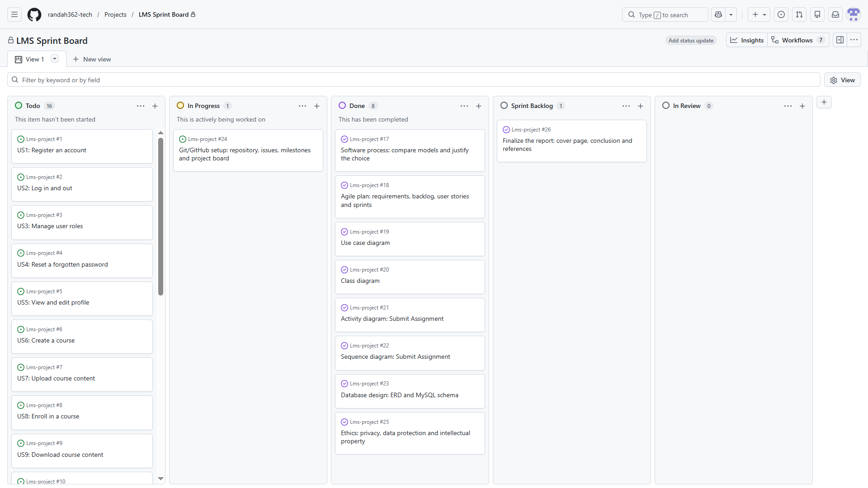

6.6 Task Distribution and Progress Tracking
The project is individual, so every issue is assigned to the student, and the work is distributed over time through the milestones and the board. Progress is measured on the ten deliverables: 8 of 10 are closed, which is 8 ÷ 10 = 80%.
The 16 user stories are the planned implementation backlog of the LMS. They were not implemented as part of this report, so they remain open in the Todo column and the three sprint milestones show 0% progress. The sprint plan in Section 3 is therefore a plan, not a record of completed work.

6.7 Pull Request
Pull request #27, "docs: review deliverables for #26", merges the develop branch into main. It contains the commit b7e3ebf ("docs: add deliverables review for #26") and reports no conflicts with the base branch. Its description says "Closes #26", so GitHub links it to the issue "Finalize the report" and closes that issue automatically when the pull request is merged. The final report is committed to develop, so it reaches main through this pull request.
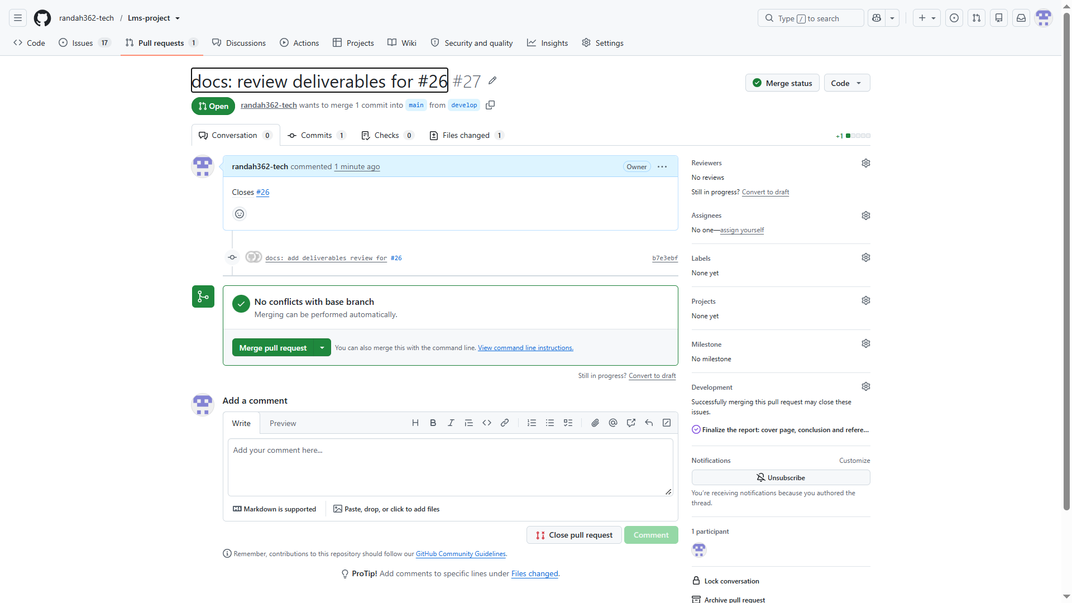

7. Software Engineering Ethics
The LMS stores personal data about students and teachers (names, emails, password hashes, submitted work and grades), so privacy, data protection and intellectual property are central ethical concerns. This section is a student's reading of the relevant rules and is not legal advice.

7.1 Privacy and Data Protection
The main legal reference is Egypt's Personal Data Protection Law No. 151 of 2020 and its executive regulations (Ministerial Decree No. 816 of 2025). Its key principles are:
- Personal data may be collected and processed only with the explicit consent of the data subject, unless the law allows another legal basis.
- Data may be collected only for specific, legitimate purposes known to the data subject, and must be kept accurate and secure.
- Data subjects have the right to be informed, to access and correct their data, to request erasure or restriction, to object to processing, and to withdraw consent.
- Transferring or storing personal data outside Egypt requires the conditions set by the law to be met, so the hosting location of the LMS must be chosen with this in mind.
The table shows how each principle is reflected in the design of the LMS.
Principle | How the LMS applies it
Explicit consent | The registration form (US1) shows a privacy notice and requires the user to accept it before the account is created
Data minimisation | Only name, email and a password hash are stored in the users table; no other personal data is collected
Security | Passwords are stored hashed, access is controlled by role, and data is transferred over HTTPS (NFR1)
Access and correction | A user can view and edit their own profile (US5)
Erasure | Deleting a user cascades to their student, teacher or admin record, enrollments and submissions; a teacher who still owns courses must first transfer or delete them
Confidentiality of grades | A student sees only their own grades (NFR2, US15)
Cross-border storage | The hosting location is chosen so that the law's transfer conditions are met

7.2 Intellectual Property
Issue | Position taken in the project
Course content | Content uploaded by a teacher remains the teacher's property; the platform receives only the right to show it to enrolled students
Student submissions | Submissions belong to the student; teachers use them only for grading
Third-party components | The authentication library and video player are used under their licenses, and their licenses are listed in the repository
Plagiarism | Students must cite sources in their work, and teachers can review submissions before grading
Legal basis | Egypt's Intellectual Property Rights Protection Law No. 82 of 2002 protects the works handled by the platform

7.3 Responsible Use of the Software
Concern | Measure
Fairness in assessment | Only multiple-choice answers are graded automatically; assignments are always graded by a teacher (US13, US14)
Transparency | Students can see their grades and which items are still pending (US15)
Accessibility | The interface works in desktop and mobile browsers (NFR5) and follows basic accessibility practice such as readable text and keyboard navigation
Avoiding harm | Role-based permissions prevent a user from changing another user's data or grades
Professional honesty | Known limitations of the system are documented rather than hidden
These measures follow the ACM Code of Ethics and Professional Conduct, in particular its principles to avoid harm, respect privacy, honor confidentiality, respect intellectual property and be fair.

8. Conclusion
This project applied the main practices of software engineering to an online Learning Management System. An incremental process with Scrum was chosen after comparing five process models, and the Agile plan turned 16 requirements into user stories with acceptance criteria, 56 story points and three sprints. The system was analyzed and designed with a use case diagram, a class diagram, an activity diagram and a sequence diagram, and the design was mapped to a ten-table relational schema with an ERD and a MySQL script. The work was managed in a GitHub repository with a commit history, 26 issues, sprint milestones and a project board. The ethics section linked privacy, data protection and intellectual property to concrete design decisions.
The project has limits. The user stories are a plan and were not implemented, and only one pull request has been used so far.
Future work:
- Implement the three sprints, starting with registration and login.
- Add question and quiz result tables to the database, so that creating and taking quizzes (US14 and US16) is fully supported.
- Work on feature branches and merge them through pull requests that close the matching issues.

9. References
- Arab Republic of Egypt. Personal Data Protection Law No. 151 of 2020.
- Executive Regulations of the Personal Data Protection Law, Ministerial Decree No. 816 of 2025.
- Arab Republic of Egypt. Intellectual Property Rights Protection Law No. 82 of 2002.
- Association for Computing Machinery. ACM Code of Ethics and Professional Conduct, 2018.
- Schwaber, K. and Sutherland, J. The Scrum Guide, 2020. https://scrumguides.org
- Conventional Commits Specification, version 1.0.0. https://www.conventionalcommits.org
- GitHub Docs: Issues, Milestones and Projects. https://docs.github.com
- Software Engineering course lecture slides on software processes: plan-driven and agile processes, the waterfall model, incremental development, and integration and configuration.

